Update DUO on your new phone
Step 1: Click on settings
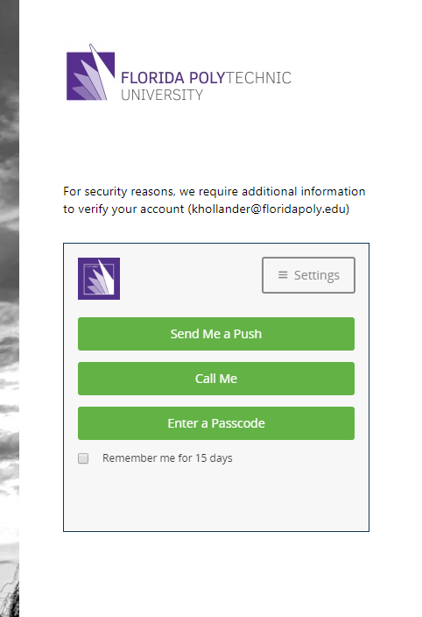
Step 2: click on add a new phone
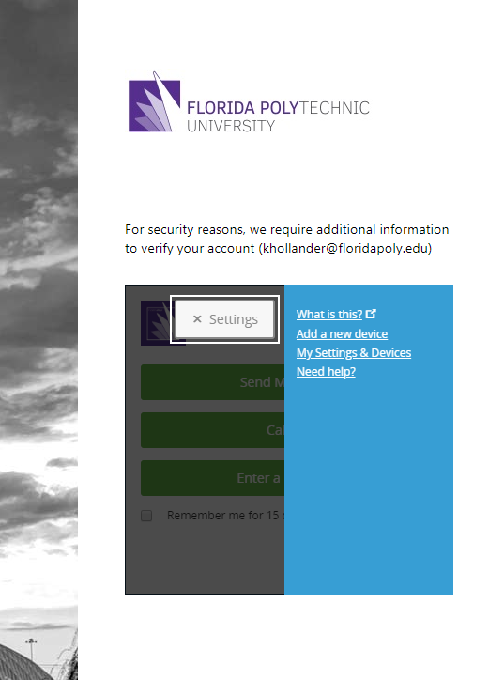
Step 3: Have DUO identify you (Choose call if you no longer have access to DUO on your device)
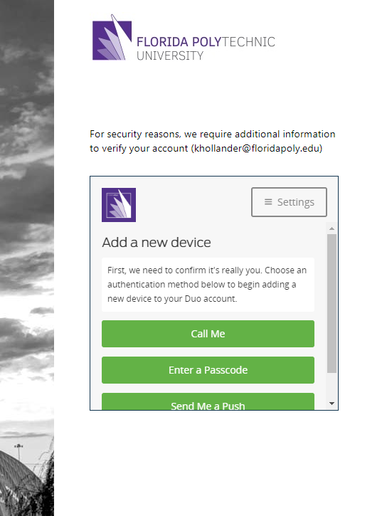
Step 4: Choose the device that you are adding.
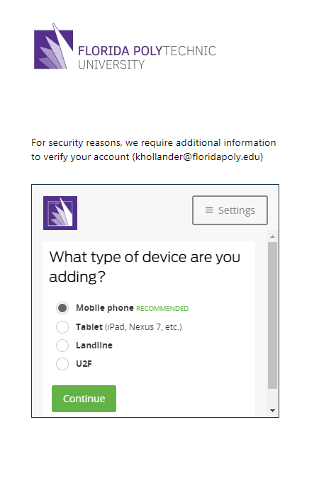

Step 5: Enter the new Phone number (Click the checkbox if it is an old phone number you are reusing)
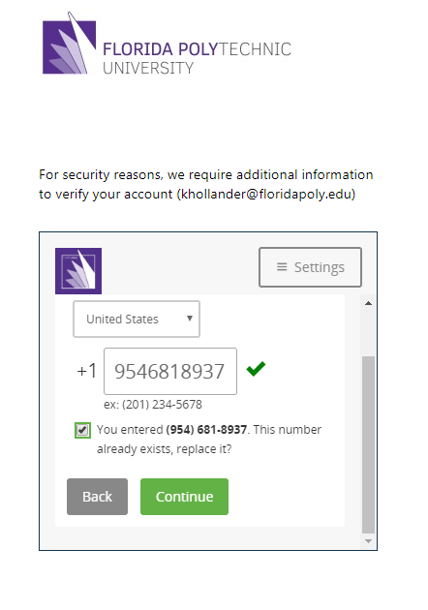
Step 6: Choose what type of phone
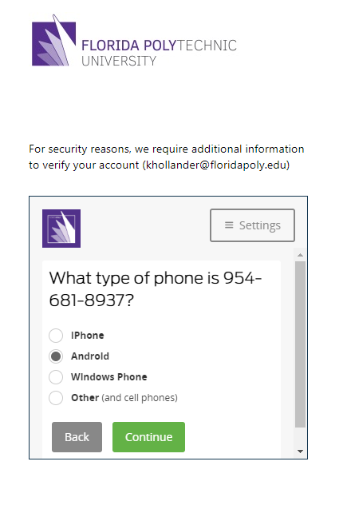

Step 7: Verify that DUO is installed
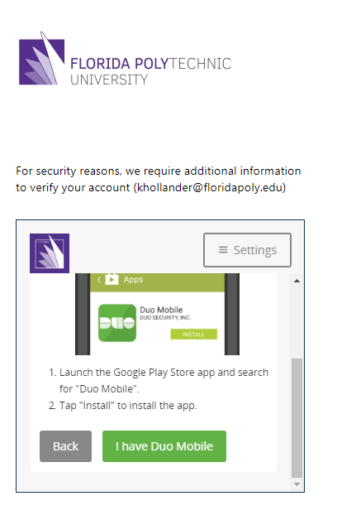
Step 8: rescan the QR Code
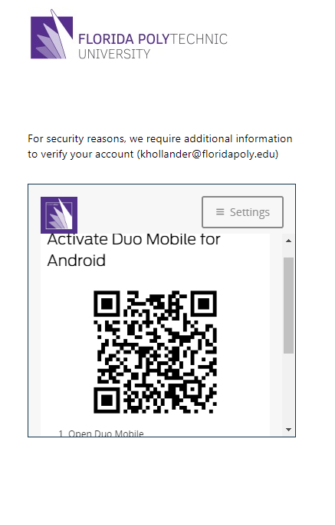

Step 9: click back to login
